**Advanced Sprint Part 3**

**Carl Wentzel**

**SSRS**

**Set-Up**

The setup for the reporting system was straighforward, except this time having to run the wizard multiple times to get the data available for reporting.

**Design**

I wanted to ensure contrast and consistency throuout the report.

**Color scheme**

* Gray, Blue & White with a logo to the bottom right in the footer.

**Font**

* Arial, with sizes that are consistent in each report.

**Font Sizes**

* Header – 24pt
* Navigation – 8pt
* Text box Headers – 10pt
* Data under headers – 8pt

**Report Size**

* Able to fit in a PDF format.

**Logo placement**

* Bottom left in the footer

Any othere neccesary additions will be implemented in a way that stays consistent.

**Text Box Groups**

**It was important to represent the data in groups for the easiness on the eyes when reviewing the report.**

**Below are the groups for each report:**

* **Crime Report**

* **Rental Value Report**

* **School Report**

* **Transport Report**

* **House Value Report**

**Functionality**

**Paremeters**

Given the task main focus is to display the data with State, City and Suburb, I want to give user the option to select from these options in a casscaded way, so that each selection is filtered in the next paremeter selection.

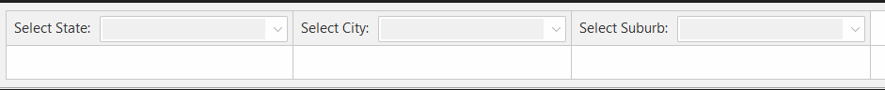

**The paremeter set up is consistent in each report, with distinct ordered by queries for A-Z selection.**

* Distinct State is the query for State Parameter
* Sub_Disintct_City is the query for City Parameter
* Sub_Distinct_Suburb is the query for Suburb Parameter

**Navigation**

Having a navigation to go from one report to the next was a useful learning experience in SSRS to allow users to jump from one report to the next. I wanted this to be available for users to click on.

Things to do – Make the buttons dominant for users to know that it is a button.



With a change of background color and tool tips, it enhaced the buttons a little for user perspective.

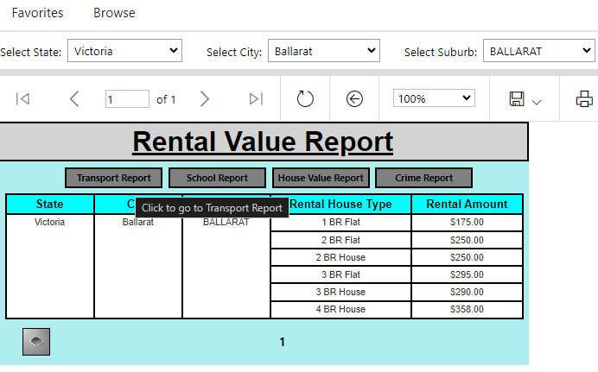

**Extra Designs**

**Report row colors**

Making each row a different color for users to glance over each line independently.

In the properties, by selecting the background color, the below code can be inserted which for this example will display every second row as Light Grey and every other row as White.

Code: =iif(RowNumber (Nothing) mod 2 = 0, "LightGrey", "White")

Due to the way my report is grouped, the color is present on just half the report which does not look professional.

**Displaying the header row when scrolling**

This was useful for reports like the Crime Report where there are more than one page when selecting a location. This is useful so that the user understands what data they are looking at when viewing the report.

This was a simple change by clicking on column groups, selecting Advanced Mode, and selecting the static that’s belongs to the headers of the table, then going to properties and changing FixedData in Other, to True.

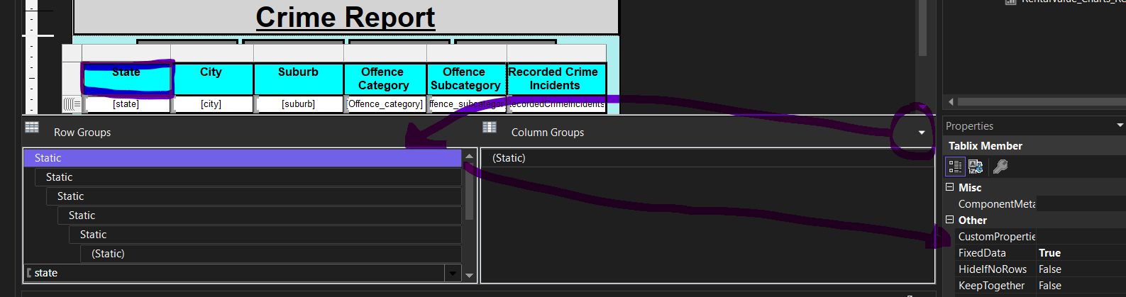

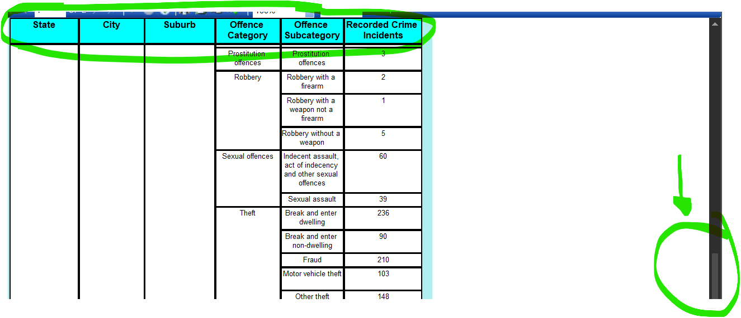

**Final Result**

With everything put together in the design and conciderable amount of deployment testing to ensure the report fit into PDF format, the below is the result show in SSRS web version.

* **Transport Report**

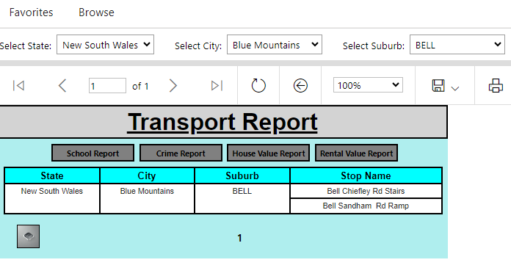

* **School Report**

* **Crime Report**

* **Rental Value Report**

* **House Value Report**

**Thank you**